### **To Supply Leftover Food To Poor – Dashboard Performance Testing**

|  |  |
| --- | --- |
| Date | 26 June 2025 |
| Team ID | LTVIP2025TMID30678 |
| Project Name | To Supply Leftover Food To Poor |
| College Name | Aditya collage of Engineeing and Technology |
| Team members | 1)Sadi ramana (Leader) – 22MH1A04D6   * [Ramanarebel69@gmail.com](mailto:Ramanarebel69@gmail.com)   2)Sravani kasireddy (Documentation developer and opearator ) - 23MHA0412   * [Sravanikasireddy850@gmail.com](mailto:Sravanikasireddy850@gmail.com) |

### **Overview:**

This document outlines the performance testing details specifically related to two key dashboards in the Salesforce-based **Leftover Food Supply Management System**. These dashboards are essential for providing real-time visibility into food donation volumes, pickup efficiency, and distribution coverage for system users, including volunteers, donors, and administrators.

### **Objective:**

To ensure that the **Food Donation Management System** performs reliably under varying workloads — maintaining speed, scalability, and system stability during real-time operations such as donation tracking, pickup scheduling, and food distribution.

### **Dashboard 1 – Operational Summary Dashboard**

**Dashboard 1** offers a high-level operational overview for food donation managers and coordinators to monitor key logistics and donation data. It includes:

* Total food donations per source (restaurants, households, events)
* A gauge for daily pickup targets vs. completed pickups
* A real-time distribution status report showing quantities delivered and pending by location

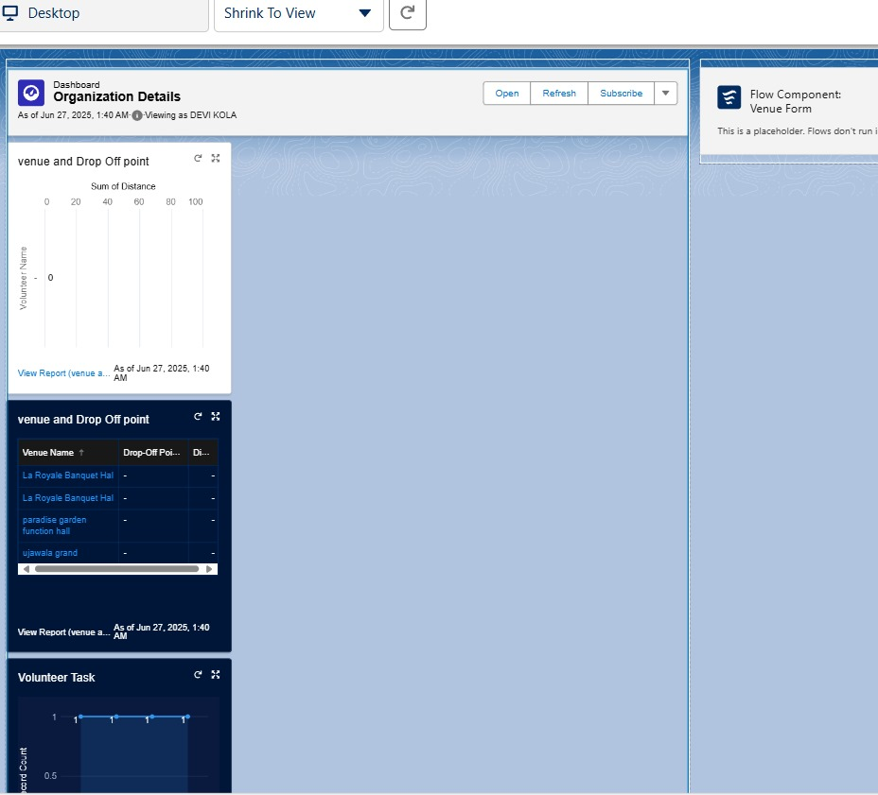

**Dashboard 1 – Operational Summary Dashboard:**

|  |  |  |  |
| --- | --- | --- | --- |
| **Component Name** | **Component Type** | **Data Source** | **Purpose** |
| Donations by Source Report | Bar Chart | Donation Object | Visualize quantity of food donated per source type |
| Pickups vs. Capacity Gauge | Gauge | Pickup Request Object | Show current pickup status vs. daily volunteer capacity |
| Distribution Overview Report | Tabular | Delivery Log Object | Display delivered vs. pending food across locations |

**Performance Observations:**

|  |  |  |
| --- | --- | --- |
| **Metric** | **Observed Value** | **Target Threshold** |
| Dashboard Load Time | ~2.8 seconds | < 3 seconds |
| Max Records Displayed | 10 | ≤ 50 |
| Gauge Render Time | 1.3 seconds | < 2 seconds |

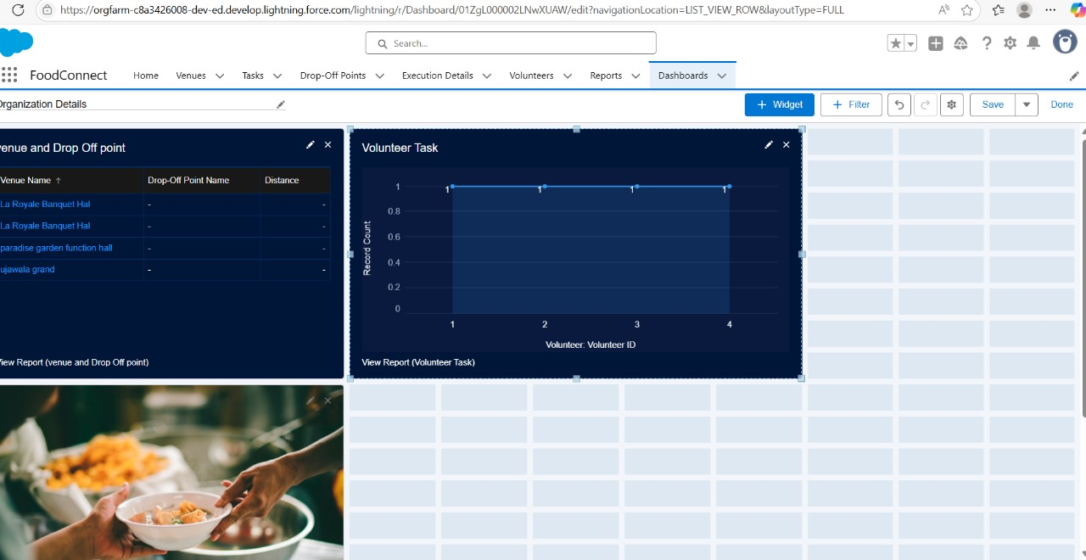

**Dashboard 2 – Analytical Insights Dashboard:**

|  |  |  |  |
| --- | --- | --- | --- |
| **Component Name** | **Component Type** | **Data Source** | **Purpose** |
| Donation Funnel Report | Funnel Chart | Donation Object | Visualize donation lifecycle (offered → picked up → delivered) |
| Food Type Distribution Chart | Bar Chart | Donation + Food Item Object | Visualize donation breakdown by food type (cooked/packaged/raw) |
| Donation Trend Report | Line Chart | Donation + Delivery Logs | Show donation and distribution trends over time |

#### 

#### **Performance Observations:**

|  |  |  |
| --- | --- | --- |
| **Metric** | **Observed Value** | **Target Threshold** |
| Dashboard Load Time | ~3.1 seconds | < 3.5 seconds |
| Line Chart Responsiveness | Smooth | Responsive |
| Funnel Chart Load Time | Moderate | < 2 seconds |